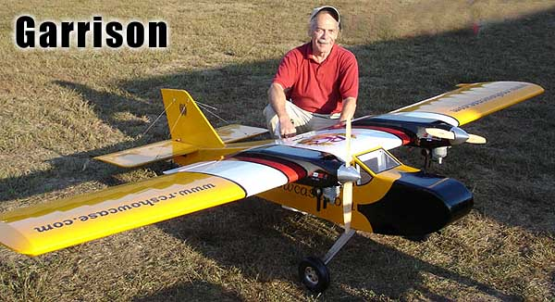
Super Flyin’ King Update #9

NOVEMBER 2005

I can’t believe it has been over a year since our last update, but the balsa chips have really been flying at BTE in 2005. In the meantime, quite a few builders have finished their Supers, so let’s take a look…

The Twins are Here! The Twins are Here!

Two different guinea pigs; uh, I mean modelers have completed and successfully flown their twin-engine SFKs. Both David Garrison of Maryland and Reg Mason of Oklahoma worked on their twins, off and on, for about two years. Many of you know David as the President of RC Showcase, importers of fine gas engines like RCS, ZDZ, and Roto. As you might expect, he used two ZDZ 40 RV engines to his SFK Twin and had nothing but good things to say about its performance. He writes:

“First flight was made by Andy Kane. Andy manged to squeeze in half of a rolling circle, a knife edge pass, a high speed photo pass, two spins and assorted other stuff all while I held my breath... Three flights were made and the SFK Twin was acclaimed “a KEEPER.” Very stable and docile, but very capable of more than flying in a straight line. Andy tried a torque roll, but only managed to hang it on the props...next time he says he will torque roll it! This plane has LOTS of power.”

David’s twin weighs 41.5 lbs., which includes 1-1/2 lb. in the nose to balance. The sleekly-cowled ZDZ 40 RVs swing 20x10 Bambula propellers. Lots of thrust!

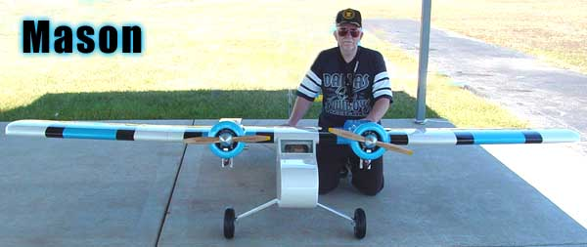
About two weeks after David’s maiden flight, Reg Mason got his SFK Twin in the air. Reg did a fantastic job of documenting his masterpiece with photos during construction. His bird features countless upgrades and modifications, like fowler flaps, hatches on the top of the wing to access the joiners, and beautiful custom-made cowls. To fully appreciate what Reg did with his model, you need to absorb the long building thread on RC Universe. You can find a link on my website under “Resources” on the SFK page. He summed up the building experience like this:

“I have enjoyed building the King immensely and have learned some invaluable techniques in model building and innovation. I would recommend this experience to everyone. I want everyone to know much I appreciate the personal information and support that you provided. A Super Flying King may not be everyone's cup of tea, but a Bruce Tharpe Engineering kit should be. Long live the King!”

Reg used Zenoah G-38s swinging 18x10 props, and his model came out at 46 pounds. He commented that he wished he had more power, but I saw some of his flight video and it seemed peppy to me. It looked solid and stable, and still landed slow and easy. With a few radio adjustments and prop experimentation, Reg is going to get more confident and adventurous with his new giant baby.

Congratulations to both David and Reg on their pioneering efforts and successful SFK Twin projects!
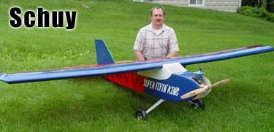
More Success Stories

Here are a few more photos of completed projects.

Tim Schuy of Campbellsville, KY now has a Flyin’ King, a Super Flyin’ King, and two Reaction 54 turbine models. He likes BTE kits! Tim’s SFK has a Fuji 64 in the nose, and he has some interesting comments:

“As far as how she handles it’s a dream to fly and I actually like it more than flying the Flyin’ King. Rolls are very axial with little input needed while the ship is inverted. Stall turns are really cool. It’s a sight to see when watching 11 feet of wing flip 180 degrees. Knife edges are really sweet. Only thing that I would have done if I were to do it again were to go with a little bigger engine. Don’t get me wrong, the Fuji does a nice job of pulling this thing around in the sky and it flies very similar to what a real airplane would do. But like Bruce, I like to fly off the wing rather than the propeller. Just takes some finesse and building of energy to perform some of the aerobatics. Notably, anything going on a vertical straight line takes some energy build-up before executing the maneuver. Had I gone with a bigger engine, this would improve. But then it wouldn’t fly as real as it does. Thus far, I have 25 flights on her and it keeps getting better. She’s a real dream to fly.”

I’ve heard similar comments from builders who have used the ever-present G-62. Engines in this displacement ballpark (60-65 cc) are okay to use; the model will not struggle to fly with all that wing area. Just beware that they are at the bottom of the recommended power range and won’t provide a lot of vertical performance.
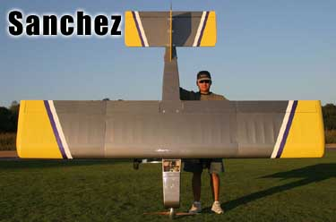
Pedro Sanchez doesn’t seem to have any vertical performance issues with his ZDZ 80-powered SFK. Pedro’s flying buddy Steve designed the color scheme and wrote:

“It's like a large, large, LARGE Telemaster with about 30 times the power. The aircraft will hover on the prop indefinitely (proven yesterday). It will climb straight up vertical once off the ground.”

It helps that Pedro’s model came out around 32 pounds, which is exceptionally light. In his email, Steve also relayed the disturbing fact that the model has bomb bay doors and a payload capacity of 24 eggs. Not sure I want to know what that is all about…

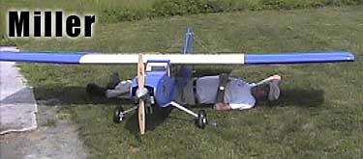
The last picture is from our good friend Russ Miller of Leicester, MA. As you can see, he has discovered an added benefit from building such a large model. Russ sent me some flying video of his SFK, and I can tell you he is a smooth operator on the transmitter sticks.

Speaking of Video…

Check out my very first attempt at making a video for the internet. I used some old footage of my SFK making a demo flight here in Oregon. You can find it on my web site, on the Super Flyin’ King page under “Resources.” Also under “Resources”, you will find detailed instructions for adding a Candy Drop mechanism to your SFK.

Keep those pictures and videos coming, friends. A nicely organized picture and video gallery is on my “to-do” list for the BTE website. The SFK family continues to grow!

Bruce Tharpe

www.btemodels.com

