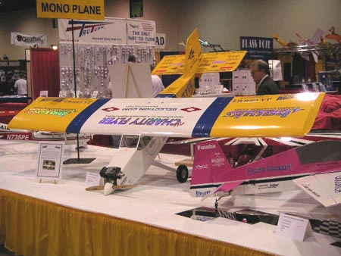
Super Flyin’ King Update #8 – OCTOBER 2004

Super Flyin’ King builders are special people. I don’t know what it is about this design, but it has attracted some of the finest people and craftsmen in the hobby. This update is dedicated to their good deeds and SFK success stories.

Charity Flyer – In this hobby, it’s hard to come up with new ideas. But a couple of years ago, a new idea popped into the head of Shawn Kappner, a member of the Hamilton Area Wireless Kontrol Society (HAWKS). His idea was to build a unique model that attracts attention, take it to local events, charge pilots a buck for a few minutes of stick time, and then donate the proceeds to charity. Simple idea - lots of work! But that wasn’t a problem for Shawn, who is a true spark plug. He assembled a team of fellow club members, and with some generous contributions from the hobby industry, they accomplished their mission and had a successful summer. Here’s Shawn with his Charity Flyer update and some good advice for all SFK builders:
The Charity Flyer at Toledo 2004.

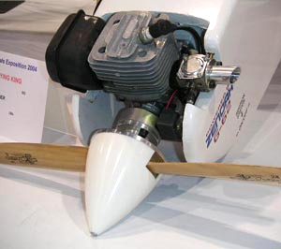
“As the Charity Flyer's season is winding down I wanted to give you a report on how things are holding up. To date 113 DIFFERENT pilots have flown the Charity Flyer including Frank Knoll. He did a number of things that were very impressive including a monster tail slide and a rolling circle. Many have flown it a number of times. It has made 37 flights and has been in the air for over 16 hours. With all of that air time, some things were bound to shake lose!!!
Normal maintenance included tightening various cables and ironing down a piece of covering now and then. Unfortunately normal maintenance included replacing flying wires in the tail every few flights. I ended up putting carbon fiber rods in the tail and that pretty much solved that problem.
The screw that holds the elevator servo horn vibrated loose. This was critical as I went with only one servo to drive the elevator. This was caught in pre-flight inspection and lock tight and a balanced prop has corrected that problem. The only other thing was the use of CA hinges for the flaps and ailerons. I used some of the best installation methods available (from Dave Patrick) and I used a lot of them. After 9 hours of flight time the flap hinges cracked. After 15 hours of flight time the aileron hinges cracked. Luckily, pre-flight inspection caught both of these so there were no mishaps. They were replaced with Robarts, which is what is on all the other surfaces.
Zenoah G-62 on Charity Flyer
Three lessons learned: 1) Pre-flight inspection is critical 2) Pre-flight inspection is critical 3) Pre-flight inspection is critical!!!!!! Everything else is very solid and I anticipate doing nothing but servicing the engine and cleaning it up a bit more than usual before storing it for the winter.”

Knowing that Shawn and his team are building a second SFK, I asked about its progress and got the following info:

“The second one is 3/4 finished. The wings and tail feathers are built and covered. The fuse is framed up but not 3-D yet. It will be completed over the winter.
The first one has had many accomplishments this year. The 1st Charity Flyer has raised over $600 for a Catholic school, Spina Bifida, a woman that had a brain aneurysm, and a young girl with leukemia. It has been used at our club as a club trainer. It was used at a local clubs major flying event in the opening parade (The GCRCC Flying Circus). Of the 113 different pilots that flew the plane, I would say that about 1/3 of them had never flown a plane before! It was on static display at the Toledo show and will be at another static show over the winter.
I let everyone know what kit it is and where they can get one. It always draws a crowd wherever I fly it. I really hope you are getting some positive feedback on the Charity Flyer. I know when I take it to different fields, I get a lot of folks saying "I saw that at Toledo", or "I read about that in the AMA magazine".

Congratulations to the HAWKS and Shawn Kappner. Job well done! You can read more about the Charity Flyer at http://www.hawksrc.org/event.asp?event=Charity

Can modeling be therapeutic? Most definitely! Especially when coupled with a strong friendship, as you will see in this incredible success story from Bob LeBlanc of Fort Myers, FL:

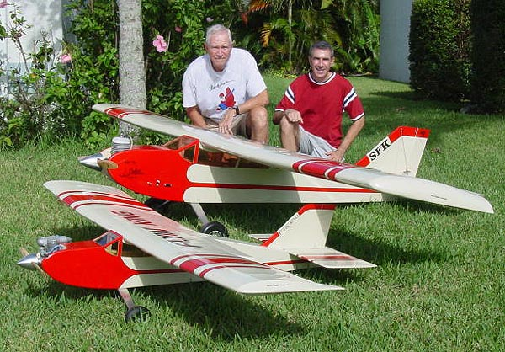
“Enclosed are some pictures of our completed Super Flyin’ King project that my good friend John and I completed together as a group project. I met John at our local field when he became my instructor. We became good friends over time developing a mutual respect for each other. We both share a fascination with flight being veterans even though we are 35 years apart. When he was diagnosed 16 months ago with a rare and aggressive form of inoperable cancer, the doctors gave him a 50% chance. The chemo and radiation started right away.

I talked to John about ordering the kit as a group project, something neither of us had ever done. Bruce was sold out of the new kits but sent his own personal 30 page working copy of the instruction manual for us to look at and mentally prepare for the project while we waited for the kit. When it did come, John worked furiously on the wings while I worked in my garage on the tail and fuselage. Everything seemed to be going good.
John (left) and Bob with their SFK and FK. Quite a pair!

About 6 weeks into the project and 2 months into treatment, the chemo got the better of him and he was hospitalized with pneumonia. It looked like he might not ever be coming home at one point but he kept up the fight like only an old marine would. During that week in the hospital, he designed some different covering schemes in his head but was too weak to put them on paper. His family rented a hospital bed for his home to get him to a better atmosphere. They set it up next to his work bench with the partially constructed panels of the 11-foot wing where he could think about important things like model building rather than medical stuff. He regained the strength to put his covering schemes on paper, then 3 weeks later, was back into the project. It was going pretty slowly but it didn’t matter. It was going and he was coming back!

When I finished the fuselage assembly and brought it over, we ended up spending much time working together on the many different challenges that came up since neither of us had ever built a model this big. It was very rewarding to jointly develop the ways to overcome them. This wasn’t so much about building a model as it was about having an exciting, fun, giant project for John to think about and look forward to being the test pilot for instead of thinking about cancer.

On December 19th, 2003, he was given the results of his final scan after completing 6 months of chemotherapy and was cancer free. We finished the project in March and John flew its maiden flight on April 1st, 2004. What a great day to see him fly this model in excellent health. The Sky King flew very well and continues to today but this model was all about the journey, not the flying itself. As far as I’m concerned, Bruce’s model completed its mission on December 19th, 2003. Thanks Bruce!

Flying this with John makes for a great half day event where we stop at the local airport on the way back for a coke and watch the full scale guys. This has been one fun project and just as fun putting it all together at the field and discussing what the next flight needs to accomplish. We both really get a kick out of having it lined up with the 33%-40% aerobats and everyone asking about the big high-wing airplane. It's just nice to see something different sometimes.

P.S. We had so much fun building the big one that we made the “little” one recently as well. This time, John built the fuselage and tail while I got some experience building wings. The 80” model is about half the size and ¼ the weight. When the hurricanes give us a break, we’ll get together and fly that one. John says that it’s my turn for the test pilot duties.

Sky King: 3W-75, Ultracote, Hitec 705’s, 2-door candy bay (2 retracts), smoke, 2 JR955s, 2 1700 mAh NiCad, 41 lbs.

Flyin King: Magnum 1.08, Ultracote , Hitec 645’s, 1 door candy bay (1 retract), JR 955, 1700 mAh NiCad, 10.5 lbs.

What a fantastic story! Bob actually understated his role in this. He came up with the idea and bought for the model for his friend. In earlier communications, he told me that both he and John thought it might be John’s last model and wanted to build something special. For me, it was both an honor that they chose the SFK, and a heartache that I didn’t have kits ready to go. Bob kept me up to date during the whole emotional roller coaster, and to say that we’re all pleased with the final outcome is another huge understatement. This one touched me deeply, and I like to think the SFK played a part in John’s recovery. However, it’s obvious from the story that it was a special friendship that really played the major role.

A See-Through SFK – Is it me, or do transparent coverings just seem to make models appear lighter? Doug Faubion decided to show off the bones of his SFK with transparent yellow on the left and blue on the right. Different, and cool! I asked Doug for some details on his masterpiece, and he obliged with the following:

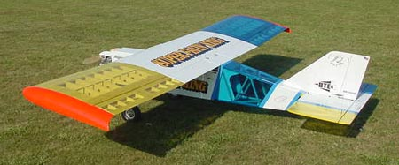
“Yes I did build flaps but have not tried them yet. The weight of the bird is 36 lbs, I had to add 1 pound of the L word to the nose to balance it at the 8 inch mark. I used 6 each of the Hitec HS-705MG servos and one HS-425BB for the throttle. The engine is an OS FF-320 Pegasus with a Zinger 22-8 prop. The covering I used is Ultracote 2 - blue, 2 - yellow and one extra long roll of white. The Radio stuff is Futaba FURL0823 PCM 8 Ch receiver and the transmitter is a Futaba T9CAP. I used an Electro Dynamics Power isolator so I have a 1900 Ma bat to run the servos and an 1100 Ma bat to run the receiver, both batteries are 6 volt. I also have on board LED voltage meters.
I have only been in the hobby for about two years and have built about 15 planes so far, I have always had someone else do the test flights for me, but I decided to be the first person to fly this one, what a joy to see it fly so great. I haft to tell you that I was on some kind of high when that first flight was over. WOW.”

Wow is right, my friend! Congrats on that maiden flight. By comparison, the first airplane I test flew had a Cox .049 in the nose and was twenty times lighter than yours. And it was nerve-wracking! Your first maiden flight was truly special – I hope that feeling stays with you a long time.

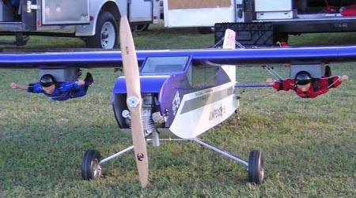
Jump for Joy – Some of you may recall in Update #5 a success story about the first customer-built SFK to fly. Rick Arrowood of Troy, OH, built his SFK to launch an R/C parachutist, and finished his bird in a whimsical color scheme with the words “Jumpers R Us” in bold letters on the side. Well, Rick’s good buddy John Bradley of Athens, GA saw the jump plane at Toledo and loved the concept. But one jumper wasn’t enough for Rick – he wanted to launch three! Here are John’s brief comments on his workhorse:

“Hi Bruce, yeah it's covered in Monokote, Kirbys Kustom Graphics cut all the Graphics, it's powered by 3W75. All JR equipment. Total flying weight with 3 Jumpers is about 51 lbs. Still flies great, thanks for a perfect Jump Plane.”
John’s Jump Plane – I believe the third jumper, when used, is carried under the fuselage.

Must be quite a show when John comes to the field…

Wrap Up – The file size on this update has grown pretty big, so I’ll wrap it up at this point. There are still a couple of success stories that will have to wait until next time. If you have some photos or tips to pass along to SFK builders, please send them to me and I’ll get them into the next update. Oh, and be proud that you’re part of a special group!

Bruce Tharpe

