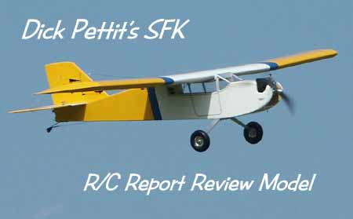
Super Flyin' King Update #6 October 26, 2003

The biggest news lately is the kit review that appeared in the October issue of R/C Report. The writer was none other than Dick Pettit, perhaps the most prolific modeler in the country. To put this in perspective, the kit was delivered to Dick at the Toledo show last April and the review appeared about six months later. In the meantime, he squeezed in a number of other reviews and a monthly column. Incredible!

In the interest of technical accuracy, allow me to correct a few minor mistakes and comment on some of Dick's findings. I'll put the article excerpts in quotes, followed by my responses.

"I counted up all the parts included in the Super Flyin' King kit, and there were almost 400 pieces of wood." Egads, he's right about this one. Problem is, I didn't know that - and I was pretty shocked to find out!

"With the ribs in place, the upper spars are installed, and one of them is even supplied tapered to match the curvature ot the top of the ribs." Actually, the front edge of the top rear spar is beveled slightly so all of the shear webs and wing joiner webs can be glued to a flat surface. (Told you they were minor corrections!)

"With one side complete and allowed to dry, a second side is built right over the first, with a sheet of wax paper between them." That's okay if you want to do it that way. However, the thickness of the sticks can vary, so you should sand the surface of the first side to make it nice and flat. Personally, I like building them separately.

"Here again, the plan is only used as a reference, since the fuselage is actually a bit narrower than shown on the plan." Once again, this is very minor. The SFK fuselage is a bit wider than the what's shown on the plan.

"The large Sullivan wheels use 1/4" bolts, and wheel collars act as spacers to attach to the main gear." BTE supplies 5/16" bolts and nuts with the optional Main Wheel Package. The holes in the landing gear are 5/16".

"Once the firewall and landing gear plate are complete, they are glued into the fuselage with 30-minute epoxy, and pinned with a bunch of 1/8" hardwood dowels for added security." Good idea. This is time-honored method of locking structural components together on vibration-prone big birds, and it's well worth the time.

"It was back on the ground, and it flew just fine, but I'm going to have to learn how to make better landings with this thing! I think it lies about its airspeed! I mean, how could I misjudge it so badly?" Dick made three attempts at his first landing because the SFK kept floating on by during the first two approaches. There's a great lesson here: The SFK is easy to fly, but its humongous proportions may take you by surprise on your initial test flights, especially when it comes time to land. Keep an open mind, be prepared to go around, and you'll soon be making some of the prettiest, softest landings you've ever seen.

Dick used a good 'ol Zenoah G-62 in his model and sounded pretty happy with the results. Of course, I'm equally happy with the positive review and want to thank Dick once again for his professionalism and speedy work. If you haven't seen the review and want to read all ten pages of it (not counting the fantastic cover!), be sure to beg, borrow, or steal the October issue from a flying buddy. Better yet, contact R/C Report (http://www.rcreport.ws or call 256-539-3031) for a back issue and subscribe at the same time. It's the best magazine on the market for traditional R/C modelers like us.

Super Flyin' King Update #6, Continued...
PAGE 2

Builder's Tip: SFK builder Russ Miller lives near New York City where mouth-watering delis seem to be around every corner (not so in Oregon). He's found that if you ask real nice, they will supply you with a generous chunk of butcher paper at a price that cannot be beat. Russ didn't like the idea of hacking away at his plans to make servo lead tubes, so he used some of that butcher paper instead. Great idea Russ, but let's end it there - I don't recommend covering your SFK with butcher paper, even if it is a thousand times less expensive than Monokote!

Video: I brought my SFK to the IMAA Rally of Giants in California last June, and made several enjoyable flights. Also there was Jeff Stein of Goin' Vertical Video, based in Nevada. Well, Jeff has released his video of the event with lots of gorgeous airplanes and some spectacular flying. Featured right at the beginning of the tape is a short interview with yours truly and a very nice series of SFK flight clips. I paid $14 for my copy, so I guess that's the going rate. Give Jeff a call at 702-648-0563 if you'd like to get the tape. Oh, and keep in mind that I'm a model airplane designer, not an on-camera performer...

Success Stories: The very first SFK customer, Walter Grabinsky of Canada, has finished and flown his bird. Walter's the guy who originated the SFK idea, so I was particularly pleased to hear his success story. He used a Brison 4.2 (70cc) single-cylinder engine and reports it flies like a charm at 38 pounds.

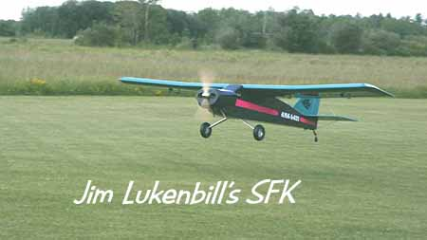
Jim Lukenbill equipped his SFK with a Fox 4.8 (79cc) twin with Bisson smoke mufflers turning a 24 x 10 Zinger. He's using a single Hitec 5735 servo on the rudder and the elevator, Hitec 5945s on each flap and aileron, and Hitec 545s on the tailwheel and throttle. He installed one receiver with two switches for his two 4000 mAh NiMH batteries. A third 4000 mAH battery powers his ignition and a fourth runs a TME smoke pump. The model carries a 50 oz. fuel tank and a 32 oz. smoke tank. As you can see in the photo, Jim built up a beautiful cowling to house the engine. The cowl is all wood and covered with Monokote. The firewall was moved aft 1.5" and made the same width as bulkhead F-2 to make a bit more room for the engine. Jim writes: "With the 16,000 mAhs of juice onboard, the cowl, and twin engine, mine comes in at a mere 41 pounds. But it flies like a dream, and I don't regret the extra weight a bit." Thanks for all the info, Jim - that's the kind of in-depth info that other builders will find useful. And thanks for the beautiful photo of your stunning SFK. For more info and pics on Jim's bird, be sure to visit his website at http://www.rcsites.net/lukenbill/projects2

At the Rally of Giants mentioned earlier, I had the pleasure of flying another SFK owned by Glenn Bennett. Glenn and his builder were skeptical of the wing joiners, so they added double wing struts on each side. They weren't necessary in my opinion, but they certainly added a ton of strength to the overall structure and gave the model a unique look. Glenn, like a lot of other builders, went with the 3W-75i like I used in the prototype.

Nose Gear: In an earlier Update, the Robart Nose Gear was mentioned as a possible accessory for builders who wanted a tricycle-gear SFK. I found another one that might actually be better - and cheaper to boot. Check out the Basic Steerable Nose Struts from Sierra Precision Components at http://www.sierraprecision.com/prod19.html
I don't have any dimensions, but their big 5/8" diameter strut looks pretty beefy and it's only $90.00. I've seen the products from Sierra Precision at Toledo, and can vouch for their quality machine work.

Super Flyin' King Update #6, Continued...
PAGE 3

Twin-Engined SFK: Now for something a little different. At the request of a customer, I've developed plans and parts for a twin-engined version of the SFK. This should be a fantastic model!

The only changes to the design are in the wing center panel. The optional Twin-Engine Modification Package includes plans for the new wing center section, plans for the nacelles, construction guidelines, and all the wood parts for the two nacelles. The package is only $75.00, and is meant to be a stand-alone option for the regular SFK kit. In other words, there will not be a special Twin SFK kit. To build a Twin SFK, you need to purchase a regular SFK kit and the Twin-Engine Modification Package. If you already have a kit but haven't built the wing center section yet, you can get the twin package and give it a try. And when I say "give it a try," I mean just that - you're kind of on your own with this special version. I haven't built a Twin SFK and don't plan to any time soon. Please understand this is for adventurous, experienced builders and fliers who are willing to take the chance on a partially-unproven design.

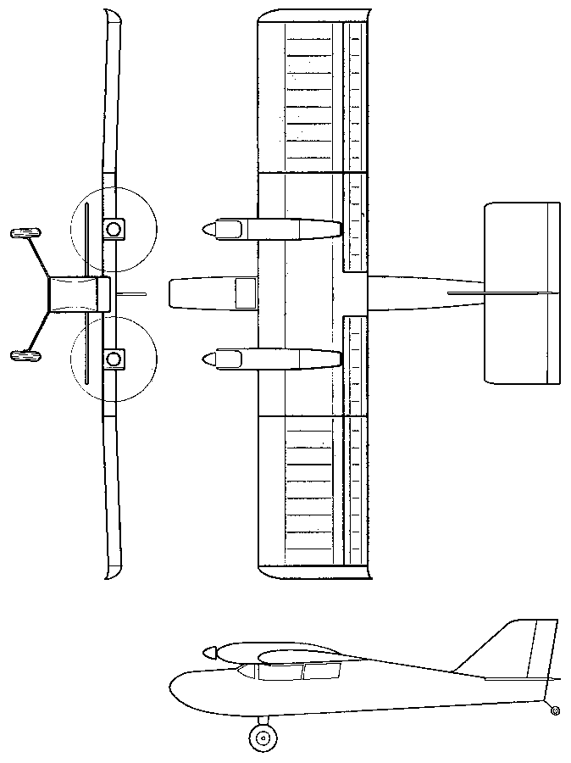
One nice thing about the twin is that it opens up the list of usable engines to glow 2-cycle and 4-cycle units. The recommended engine range for the Twin SFK is as follows:
GLOW, 2-Stroke:
GLOW, 4-Stroke:
GAS ENGINES:
24cc - 34cc (1.5 - 2.1 c.i.)
30cc - 40cc (1.8 - 2.4 c.i.)
30cc - 40cc (1.8 - 2.4 c.i.)

Wrap Up: That does it for this Update. Please let me know about your success stories, tips, and suggestions for the next one.

Bruce Tharpe
1-800-557-4470

