Super Flyin' King Update #2 October 2, 2002

Gentlemen,

Sweet success! The prototype SFK flew for the first time on Tuesday, October 1. All I can say is "Wow!" Actually, I can say a lot more. It flew a total of four flights and all went very well. Like all nerve-wracking test fights, the maiden voyage had to end in a dead-stick landing, of course. Not a problem - she glided in like an eagle and settled on the runway, flaps down, right in front of me. Whew!

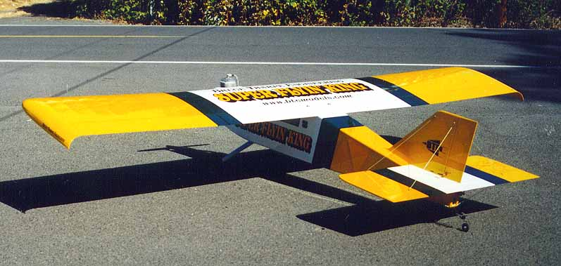

As you can see, I stuck with my usual Flyin' King color scheme, but changed the blue bands to metallic green. Looks good to me. The giant graphics were cut by my friend Bill Fulmer in Louisiana. I highly recommend him for vinyl graphics. If anybody walks up to this model and asks me what I call it, it will be obvious that they are in dire need of an eye exam...

Notice the tail braces. I finally decided they were necessary, especially with the removeable tail unit. The fin is basically butt-glued to the stab except for the trailing edge which extends through the stab and is braced below. The front of the fin fits into a slot in the fuselage, which doesn't provide much support. The braces you see were my first attempt; 2-56 rods with clevises at each end. Well, during engine testing, a clevis broke and damaged the covering on the fin. Dang it! Oh well, I pulled those off and replaced them with nylon-coated steel cable which seems to be holding up well and is lighter anyway.

I'm happy with the landing gear. It's heavy, but I've been known to tend towards the light side for my designs in the past. This one is plenty sturdy. The Sig tailwheel unit works great. I have pull-pull cables going to both the rudder and the tailwheel, driven by the same servo. So far, so good.

Another area of concern was the wing joiners. I figured a tough test would be to pick up the assembled model at the wingtips (takes two people, obviously) and shake the darn thing! No problem. In the air, the load is distributed along the entire wing, not just he wingtips, so the ground test was more brutal, and safer. In the test flights, I couldn't bring myself to do any hard yanking on the elevator just yet, but there was no problem with what I would call "normal" flying which includes turns at full-throttle, loops, rolls, and touch and goes. Bottom line is I no longer have any concerns about the wing joiners.

Turns at full-throttle doesn't sound like a biggie, but remember I chose a pretty big engine for this bird. It's a 3W-75, and so far it seems like a good engine. The dead stick landing was more a problem with a sloppy throttle linkage that allowed the engine to go too slow. Getting a consistent slow idle is my only real problem, and that will improve when I re-do my throttle linkage and the engine gets some time on it. At top end, it's a brute. Like my smaller Flyin' Kings, it was more pleasant to fly around at 1/4 throttle than at full throttle. Cactus Aviation told me this engine would put out 42 pounds of thrust, which is plenty for a 36 pound sport model. Truth is, it wouldn't pull this model straight up, so maybe it needs more break in. Time will tell.

Oh yeah, 36 pounds. Before running the engine, I was kind of disappointed and wished it had come out lighter. After running the engine, I wished it was a little heavier! Now that I'm getting used to the engine and the vibration, it seems about right. It could still be lighter with different radio equipment (mine has a lot of big, heavy servos, dual batteries). Of course, when a model this big takes off in less than 20 feet, how much lighter does it need to be?

For your consideration, my engine recommendations will probably change in the upward direction. First of all, it wouldn't be much fun with a 40cc motor like a US 41. Plus, it needs the weight of a heavier engine in the nose for balance. Mine is at the rearward edge of the range, even with the 75. A small twin-cylinder like the Zenoah Z80 might be pretty nice. Start thinking in the 50 - 80 cc range.

Kit production will begin very soon and every effort will be made to deliver kits in October. You guys are going to love this airplane! Feel free to contact me with any questions you might have.

'Til next time,

Bruce Tharpe
BTE 1-800-557-4470

