Super Flyin' King Update #1 August 18, 2002

Hello,

Thought it was about time for an official update on the Super Flyin' King project. This e-mail is going out to all of you who have ordered, or might be interested in it. As usual, everything seems to take longer than planned, so I very much appreciate your patience. To the best of my ability, I am devoting all available time to this airplane and will do so until the first batch of kits have gone out the door.
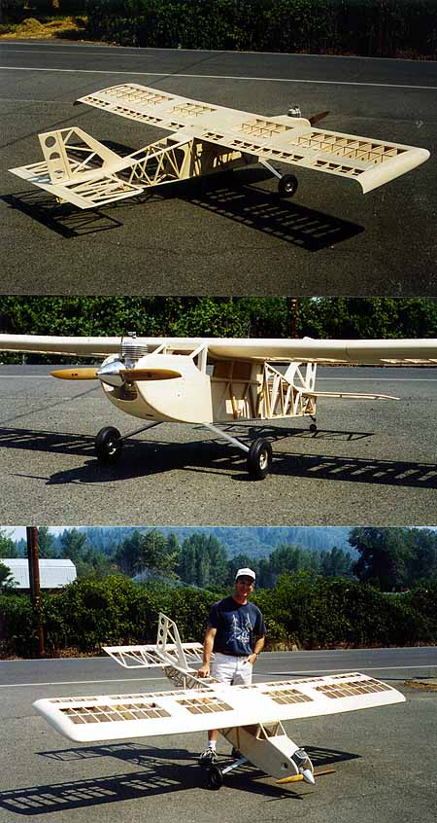
The SFK has been a real delight to build. As you can see from the photos, my prototype is nearly ready to cover. It looked very much like this nearly a month ago, but I've spent considerable time planning the installations of the engine, muffler, ignition system, dual radio system, servos, antennas, tailwheel, etc... This bird should go together pretty quickly once the ten rolls of Monokote are applied!

So far, I'm pleased and confident with the design, but the real test will be in the air. For obvious reasons, I won't be sending out any parts until the prototype has flown successfully. However, the wood has been ordered for the first batch of 12 kits, and I don't expect the actual production of parts to take very long.

Now, to the photos. I'll try to answer as many questions up front as I can. Of course, feel free to contact me with any unanswered q's you might have. The engine I selected was a 3W-75i, 75cc, rear-mounted carb, side exhaust. Yes, that's bigger than what I recommended on the spec sheet, but several of you have mentioned wantiong to use power in this range and it seemed prudent to test it out that way myself. According to Bobby at Cactus (3W distributor), the 75 will put out 42 pounds of static thrust. Should be plenty! BTW, it looks like my SFK will weigh over 30 lbs, maybe 35. Still, it will have an amazingly low wing loading for a plane this size.

The big hole on the fuselage side is for the exhaust header. I decided to run my big cannister-style muffler alongside the fuselage. Not pretty, but will give it that "utility" tractor kind of look.

Ah, those wingtips. I've always pictured the SFK with these STOL-style tips. Took me a day to carve and sand them, but it was worth it to me. Sorry, but the kit will come with flat wood tips, like the regular FK. Obviously you can add STOL tips to yours if you want. I might be willing to do a rough carving if you wish, for a price to be determined. Fiberglass tips would be great, but I don't have the time or resources right now.

I made my tail group removeable for transportation. Kind of a good idea, but troublesome too. I plan on installing tail brace wires, so remove the tail will mean undoing the braces, disconnectiong the elevator pushrods, unhooking the rudder cables, and unbolting the tail. This is an option that I will leave completely up to you.

The main gear is stout! Should be no concerns about strength here. It's 3/8" aluminum. My wheels are 7" Sullivans (they're nice!). I had 6" DuBros, but they looked too small. I'm going to use a heavy-duty Sig tailwheel unit - hope it holds up...

And for those of you who haven't met me in person, yes, that's me in the photo. Hope this helps give you an idea of the size of the SFK. It's big, to be sure, but not unmanageable. I'm dying to see it fly, and I know you're all anxious for your kits. We're gettin' close!

Bruce Tharpe
BTE 1-800-557-4470

