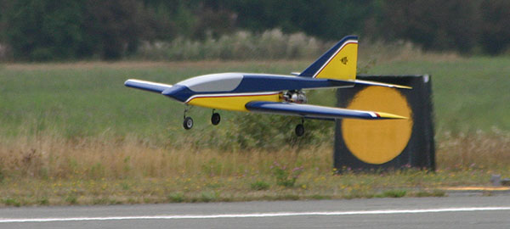
UPDATE #6 July 2006

Well, it’s been a year since the last update, and it seems like every week or two brings news of another R54 success story. There has not been a pressing need for another update because it seems like all of the builders are hanging out on the massive R/C Universe thread devoted to this model. If you haven’t seen it, clear your schedule and click on the link below.
Bruce’s R54 at Jets
Over Whidbey 2005

RCU Reaction 54 Builder’s Thread: http://www.rcuniverse.com/forum/m_2402726/tm.htm

The Saga of the Soft Nose Wheel Struts

A couple of months ago, a builder reported on a successful maiden flight but the nose wheel wire was so soft it bent way back even after a soft landing. He pulled it back into place easily by hand and flew several more times, re-bending the nose wheel wire into position after each flight. Now I’ve seen ARF pilots go through this routine, but not R54 pilots. With no spare struts in stock, I began to go through my inventory of retract sets and was shocked to find that they all indeed had very soft wire in the nose wheel units. This is a problem!

My first step was to call Robart, thus beginning what has become a two-month drama of trying to get proper wire for my nose struts. At first, they thought the wire had been improperly heat treated, so I sent them all of my soft wires in hopes they could be “revived.” That didn’t work, so they decided to make them in house. Problem was their tooling was broken, which required several weeks of repair work. Last I heard, they decided to subcontract.

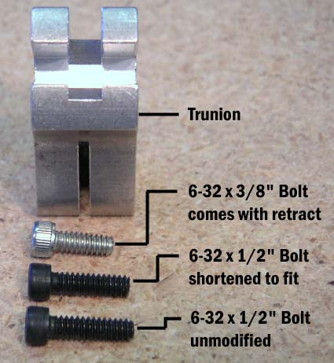
The good news is that Robart finally sent me some good nose wheel wires, and will soon send some more. Be aware that not all of the original struts were bad, just some of them. The bad ones were silver in color; the good ones are a darker metal color, almost black. The soft ones can be bent back by hand and they don’t spring back; the good ones are almost impossible to budge by hand. Please let me know if you have a soft nose strut, and I will replace it free of charge.

Keep Your Main Wheel Struts from Twisting

Moving on to the main gear, a problem that has happened to a few of us is that the strut sometimes rotates in the trunion block. After a really bad landing (my fault!), one of my main wheel struts had rotated slightly, so after twisting it back I tried to tighten the socket-head bolt. Okay, I really cranked down on it and you can guess the rest. The bolt stripped and the trunion was ruined (again, my fault). Looking at it closely, it became apparent that the supplied bolt is a little short and does not engage all of the threads in the block. Obviously, a longer bolt would be better. A 1/2” bolt is a little too long, but if you grind off about 1/32”, it will be the perfect length and will engage another four threads or so. If Robart had a source for 6-32 x 15/32” socket-head bolts, I’m sure that is what they would use.
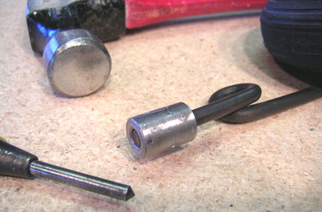
Even with the longer bolt, the gear still depends on friction to hold the strut firmly. To beat this dead horse a little further, I thought maybe roughening or distorting the strut end would increase the friction. Using a hammer and center punch, I put about a half dozen dimples in the strut end. It dimples easy, so don’t go overboard. I ended up having to lightly file the dimples to get the strut back into the trunion, but what a difference! The strut is now difficult to rotate by hand even before tightening the bolt.
PAGE 2

Important: I do not consider either of these modifications to be entirely necessary, and neither does Robart. They just suit my mechanical sensibilities and compulsive nature.

Installing the Kavan Brake

Full disclosure: Due to a time crunch, Bruce Sr. actually did my first Kavan brake installation (on the R54 prototype). I’m finishing up my second R54 now, and recently installed a Kavan unit on one of those nifty new Robart struts. This one I did all by myself, and I learned that getting it mounted straight is definitely a challenge! Hopefully, the following tips may make it easier for you if you haven’t done it already.

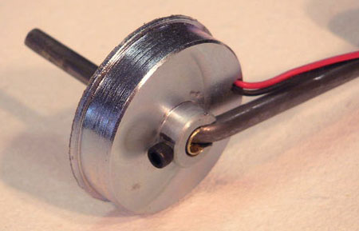
First, the axle hole in the brake is too big for the strut wire, and the brass tube that I supply as a spacer is not thick enough to fit the brake. You really need a second piece of tubing, 1/4” o.d., to slide over the 7/32” piece of brass tube. This is something I will correct in future wheel/brake packages. However, the hole in the brake is 6mm, which is not quite big enough for the 1/4” tube. The brake needs to be drilled with a 1/4” drill to fit the second spacer perfectly. Be careful with this step! I temporarily bolted my brake to a piece of plywood using four small screws around the perimeter to hold it for drilling.

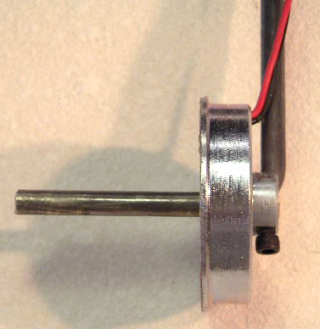
Next, you need to notch the shoulder of the brake so it will snuggle up close to the strut. Make sure you place the notch so that the wires that come out of the brake are right next to the strut. I used a Dremel tool with a cutoff wheel to make the initial cuts, then switched to a round cutter to finish the notch. The toughest part is rounding off the inside of the notch to match the bend in the strut wire. Grind, trial fit, and repeat until you are satisfied with the fit.

Finally, the set screw that comes with the brake is really too small for our purpose, so I replaced it with a 4-40 x 1/4” socket head bolt. That meant drilling through the brass tubes, then running a 4-40 tap through the existing metric threads. When the bolt was installed, it helped align the brake with the strut and removed the remaining play. Remember, the disc plate floats between the brake and the wheel, and the brake will work just fine even if it isn’t aligned perfectly with the strut.

Although some builders have opted to go with pneumatic brakes, I still think the electromagnetic Kavan brake on the nose wheel is ideal for the R54. It is inexpensive, virtually maintenance free, and adds a little weight to the nose (which the R54 needs anyway).
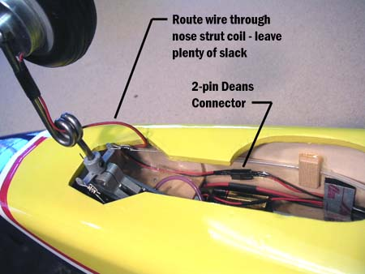
Optional Brake System Modifications
PAGE 3

Add a Deans Connector – Need to work on your nose wheel strut or retract unit? If your brake is hard wired, you will have to snip them now and splice them later. A better idea is to add a two-pin Deans connector positioned between the Kavan unit and the 9V battery connector, as shown in the photo at right.

Make it Proportional – This idea was submitted by Bob Parks. Bob is a highly respected engineer in the aerospace industry and well-known jet modeler. I consider his advice golden, so I’ll let him take it from here:

“One comment on the Kavan brake. I have one on my Boomerang, but I did the setup a bit differently. Used a small, brush motor type speed control (Castle Pixie 7) instead of a switch. You want to set up the ESC for a fixed "throttle range" (Most of them figure it out automatically each time they are turned on.. and are a bit strange until you get to full throttle the first time. Since that happens on take off for most planes, it’s no big problem, but not good for a brake!). The key thing is that you need an ESC that you can set up to use a fixed pulse width range for the throttle response. Unfortunately, almost all of them now do auto detect of the range.
“The brake pulls about 1 amp, so most any ESC will work. But the result is a nice proportional brake. Significantly more proportional than the pneumatic brakes I have used. It might even be good enough to use for main gear brakes with differential brake for ground steering...
“One Kavan on nose gear is certainly adequate for an R54 or Boomerang. I got the Boomerang flying today. It does well. R54 looks a lot better!”
See what I mean? Golden. ☺

Use your ECU Battery Instead of a 9V – John Considine submitted this idea. He writes:

“Tried the brake on the ECU pack and it works fine, no issues with the engine from the increased load on the ECU pack. The brake actually works better as the voltage on the 9V transistor battery falls quite a bit under load due to its limited current output. As long as the ECU pack voltage is within the limits for the brake, this could be a better way to go.”

Sorry, no details on how John actually wired this. I suggest you only attempt this setup if you are good with electronics and know what you are doing (unlike me!).

Use an Electronic Switch Instead of the Micro Switch – This is something I have tried (on a different model) and it works really well. You do need a free transmitter channel to control the switch. You can use a two-position switch or knob on the transmitter, but I personally think they are hard to reach, especially in a desparate situation. I programmed my transmitter to turn the switch on with full down elevator, so it works just like the micro switch.

One of my model-designing heroes, Dick Sarpolus, turned me on to the Team Delta switch. The RCATS switch looks like it would work just as well. Follow the links below for more info.

Team Delta R/C RCE200(A) Switch Interface: http://www.teamdelta.com/products/prod2.htm
RCATS RC100 Electronic Switch: http://rcatsystems.com/electronics/rc100.php

Mount the Brake on the Other Side of the Wheel – My friend Gary Cosentino of CA can only be described as a perfectionist (and that’s a good thing in my book!). He tried mounting the brake as described above, but was not fully satisfied with the fit and alignment when he was done. So, like any good perfectionist, he tried again. But this time, he went with the brake on the opposite side of the wheel. As you will see, his idea has some real advantages. Here is Gary’s description…
PAGE 4
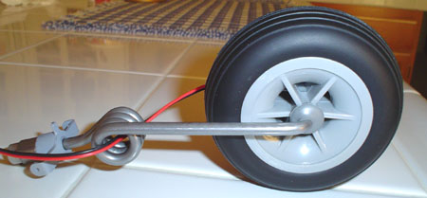
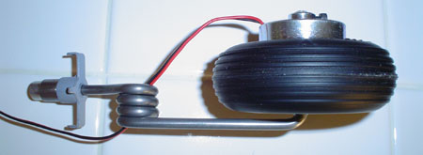
“Well, I persisted, and I finally got where I was hoping to get. As promised, check out the attached three photos. I am now very happy with the nose strut/wheel/brake assembly. Some description: steel washer JB Welded to inside of axle, followed by Hangar 9 nose wheel, followed by Kavan brake on outside of wheel. I have your supplied 7/32 brass tubing inside of the brake, and I made it a decent fit with one layer of Teflon tape wrapped neatly around the brass tubing. I then added a socket head (metric) cap screw instead of the smallish setscrew, and made a mark into the Teflon tape on the brass bushing. Removed the brass bushing and drilled through the mark with a small center drill. This allows the cap screw (setscrew) to pass through the brass bushing and contact the steel axle. All I need to do now is file a flat on the axle to really seat the cap screw (against the torque of braking), and I'm done!!
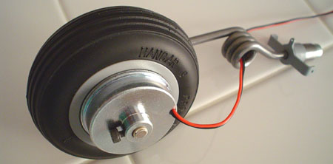
“I think it looks neater and as you can see, keeps the wheel center line very near the axis of rotation of the nose strut. Also, overall, I would think it ended up being a little more compact (width wise). I'm not too worried about the wire as it seems to want to stay away from the wheel when I pass it through the strut coil. If it threatens to make contact, I'll use a little heat shrink tubing carefully placed to encourage it to stay away from the wheel.

“Feel free to use my pictures and descriptions as you see fit if you think they'll be of help to any one else. Big advantage I see of my method is no notching of brake, which I already screwed up once!”

There is another possible advantage to this setup. A customer once told me that by notching the brake, you are removing mass that normally contributes to the electromagnetic function, thereby weakening the brake slightly. So Gary’s mounting method also results in a little extra braking power because no material is removed.

I would be tempted to add a second cap screw 180 degrees from the first one, for additional holding power. There will be a lot of torque on that housing when the brake is applied. Overall, this looks like a great way to mount the Kavan unit. Clever thinking, Gary!

Hmmm, should have called this R54 Update the “Landing Gear Issue.” Thank you very much to all the R54 builders who contributed their ideas for this update. Hope you found something useful. BTE

