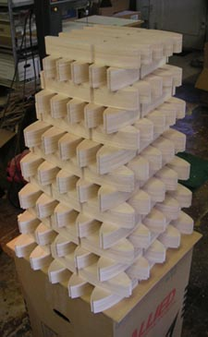
R54 Rib Stack for Run 2 – Just thought you might like to see what 1400 wing ribs stacked up looks like. Lots of work, believe me!
UPDATE #5 June 2005

The Momentum is Building

Oh my gosh, there has been so much happening with the R54 since its introduction last year, I don’t know where to start. The first batch of kits started going out the door early in December and they were sold out a couple months later. Some went to modelers who are well-known in the jet community, like Tony Frackowiak, Bob Parks, and Dean Wichmann. Most of them; however, went to the kind of modelers the airplane was designed for – accomplished builders who were ready to get their feet wet with turbine power. Once the kits were out, it seemed like every day brought a new picture or update from enthusiastic builders. Turbine manufacturers started calling me with offers to sell their products. Magazines called for review models. Wow, I guess that means BTE is officially in the jet business!

As of this writing, the second batch of kits is nearly ready to pack. Once that’s done, BTE will begin to promote the R54 in earnest. So far I’ve done very little along those lines beyond the info on my website and displaying the prototype at Toledo. With some ads, some word of mouth, and some exposure at jet meets this Summer, I’m hoping the family of R54 enthusiasts will really start to grow.
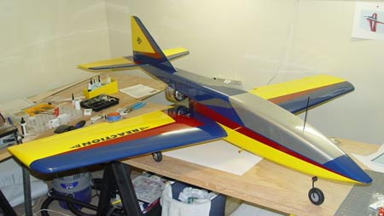
Success Stories
Schuy

A few of those early customers turned out to be really fast builders! The first customer-built R54 to take to the skies came from the shop of Tim Schuy of Campbellsville, Kentucky. Tim works for Amazon.com and has been a loyal BTE customer for several years, having built a Flyin’ King and a Super Flyin’ King. New to turbines, he was a perfect candidate to test the model’s ability to serve as an entry-level jet. Tim summarized his glowing report about the maiden flight like this: “The Reaction 54 is truly your best and it's been a great pleasure to build and it flies even better. The airframe is solid and the flight performance is phenomenal”.
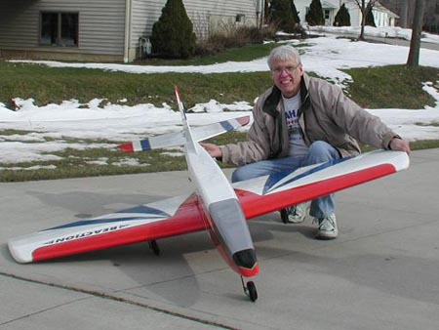
Thanks Tim, and congrats to you! You done good…
Rigotti

Tim selected the FTE T-500 for power, and ran it on an immaculate test bench setup before installing it on his bird. I highly recommend bench running, especially if you are new to turbines. There’s a lot to learn about turbine operations, even if you are the best needle valve tweaker in your club.

Next to fly was Dave Rigotti of Chesterland, Ohio. He’s really been expanding the envelope with his pretty red, white, and blue R54. Powered with a JetCat P-60 putting out 13+ pounds of thrust, Dave recently measured a top speed of 163 mph with a radar gun! Sound fast? Well, that was the speed out of a screaming dive with wide open throttle. Level passes at full throttle were 135 mph, and landing speed was an amazing 26mph with zero wind. Dave and Tim met up at the Bardstown Jet Rally earlier this month and flew some impromptu formation. Thanks guys!
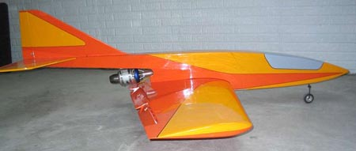
Here are some more Success Stories, in no particular order:
Szetlack

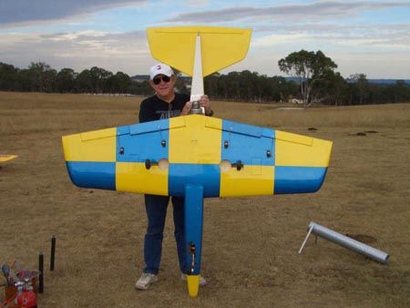
Gary Szetlack went with an easy-to-see yellow and orange color combo on his model. On his first day out, he put up five flights, the last one ending with an off-field deadstick. Gary writes, “On the dead stick the engine died at the worst possible location (surprise) and I made the landing way downwind. When she landed, she bounced so hard that one of the struts was bent in a way I didn't think possible. I removed it at home, put it in a vice, straightened it out, and inspected the airframe. ROCK SOLID. This is DEFINETLY an airplane that will stand up to rough field flying. Thanks for a well engineered kit Bruce, this one is a keeper.”
Watson

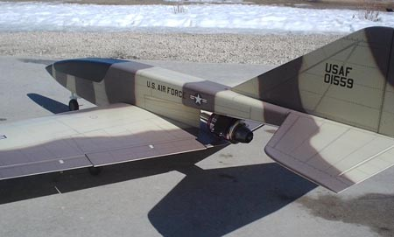
Could the R54 become an international success? Tommy Watson flew the first R54 in Australia, powered by a Wren 54 Mk. 3 (made in England). Tommy is very happy with the turbine, and extra happy with airplane. Tommy says, “This is the best flying model airplane I have ever owned. I have been flying models for over 50 years and this tops them all.” Tommy also called me a genius, so you can obviously take his comments with a grain of salt. ☺
Wiebe

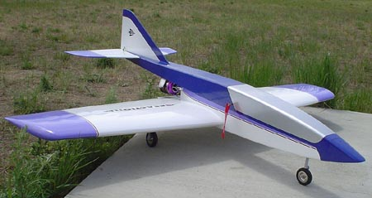
Canadian John Wiebe’s PST-powered R54 features a fantastic camouflage color scheme complete with panel lines and rivets. I love it! Perhaps his nicest compliment was about the actual kit. John said, “My first impression of the kit was finally someone is producing a kit that isn't crunched or burnt.” I appreciate that because, quite frankly, these kits take a lot of effort to produce. Congrats on a beautiful model, John.
Wichmann

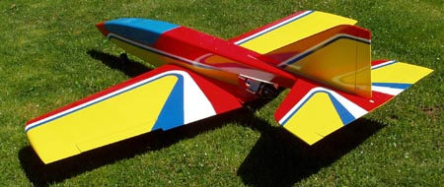
Well-known turbine distributor Dean Wichmann of Helijet R/C in Canada had this to say about his PST-powered R54: “Had several perfect flights with her yesterday and I am going out on a limb here...but....IMO your design is the best overall jet trainer available today… The kit builds very easily, the instructions are amongst the best in the industry and support is always there. Well done Bruce...” Thanks Dean, that means a lot coming from an industry leader like yourself.

Ron Jahnig of West Virginia also went with a PST J-600R and a color scheme similar to mine. Ron is an experienced jet pilot, a skilled modeler, and a man of few words. Here’s his entire flight report: “The Reaction flies great.”
Jahnig

This file is getting big. More to follow soon. Keep those pictures and flight reports coming… Bruce Tharpe

