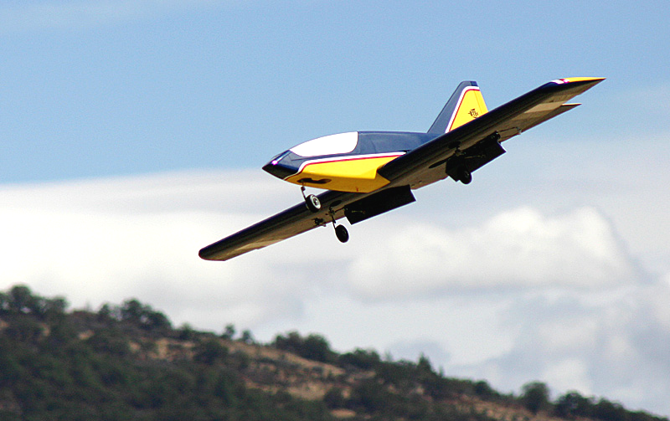
UPDATE #4 November 2004

The “Big Announcement”

Consider it done! All of the wood parts are cut. All of the kit hardware is in house and packed. My proof model is nearly complete as are the instructions. The full-size plans still need to be finalized and printed. Kit boxes are on order. The first kits will begin going out the door the week after Thanksgiving.
The Reaction 54 in its element, coming in for another smooth landing on the 400-foot runway at Bruce’s local field in Medford.

Some History

This has been a big project. Thinking back, the time line on this model covers nearly four years. The original plans were drawn up in 2000. That year I purchased my first turbine, the RAM 500, which was the hot ticket at that time. I showed the drawings to a couple of my jet friends, Tony Frackowiac and John Redmond at the AMA convention in 2001, and they were very encouraging (John took one look and said “Do it, man!”). One of my early design decisions was to use the brand new Mighty Mini retracts from Robart, which were designed for jets and fit the weight class perfectly. Unfortunately, the R54 prototype was delayed while waiting for Robart to bring these units to market. I spent most of 2002 developing the Super Flyin’ King kit, which was very satisfying, but the R54 continued to beckon. With retracts now in hand, the prototype was built, covered, and put on display at Toledo in 2003. A summer of rigorous test flying followed and the decision was made to go ahead with the kit. Delays occurred again due to the popularity of the Super FK and other BTE kits and the need to keep them in stock. Finally, something had to give. My Venture 60 kit was put on hiatus to allow time to work on the R54.

I have now been focused almost exclusively on the R54 kit for the past six months. During that time, I have received a lot of inquiries about the kit from eager builders around the country and around the world. Several of you have become true friends with your help and encouragement. There’s no doubt that some have moved on to another design or model, but many of you have been patiently waiting for this kit and tracking its progress. To those of you who have been waiting, let me first extend an apology for taking so long. Second, please know from the bottom of my heart that I appreciate your extreme patience and hope that you will consider the R54 to be worth the wait.

So Let’s Talk About the Kit

Just to scare myself, I counted up the number of wood parts in the R54. There are 221, most of which are accurately machine-cut. Those of you who have built a BTE kit know that we do not use die-cutting or laser- cutting. The parts are machine-sanded using aluminum templates (see Update #3) for accuracy and a perfect fit. You will find things in this kit that you may have never seen before. The leading edges of the ailerons, flaps, elevator, and rudder are all beveled along the hinge lines. The front edge of the bottom main spar is slightly beveled and aligned with the top spar so the shear webs make solid contact. The plywood nose wheel retract mount is angled on its bottom edge to match the slope of the fuselage bottom. The bulkheads already have holes for wiring, retract air tanks (2 sizes), and control linkages. A hardwood wedge is provided to mount your turbine at the ideal thrust angle. Jigs and templates are provided to make the building process fast and fun.

R54 Update #4 – Page 2

There’s much more to this kit than just wood! The five CAD-drawn plan sheets show detailed installations of servos, retracts, batteries, ECU, etc… The instruction book is printed in color with lots of photos. I know that all of you are experienced builders, but I figure too much information is better than too little, right? The kit also includes an aluminum engine mount, either the RAM-style or PST-style, your choice (see Update #3 for details). A stainless steel heat shield is included to protect the bottom of the fuselage from turbine heat, and aluminum tape is provided to cover up the edges of the heat shield. Vinyl graphics (not decals) of the R54 and BTE logos are in the kit, and fiberglass tape is supplied to reinforce the wing center joint.

The R54 was designed around the Du-Bro 50 oz. fuel tank, so one of those is also included in the kit. For safety, a neoprene rubber pad is provided to cushion the front end of the tank against a solid bulkhead just in case, heaven forbid, the R54 meets the Earth in less than a stately fashion. It may be just enough to prevent a tank rupture and possible fire. Note also that the turbine is separated from the tank by substantial structure which may also help avoid post-crash fires.

Wait until you see the high-quality hardware that comes with the R54! Everything you need for rock-solid linkages to the control surfaces are provided in the kit, including steel Sullivan control horns, steel 4-40 clevises from Sullivan and Du-Bro, steel 4-40 threaded couplers, and a healthy assortment of screws, nuts, bolts, and washers. You also receive Sig Easy Hinges for all the control surfaces (don’t laugh – I love these hinges and they will hold up just fine in your R54). A sturdy, spring-loaded hatch latch is included for the front hatch. Two sizes of rubber grommets are provided for where the turbine wiring and fuel lines enter the fuselage. Cup hooks are provided for lashing down your receiver and batteries, and it even comes with the rubber bands!

On the down side, the kit will not come with a razzle-dazzle label on the outside of the box. Sorry.

BTE Reaction 54 Kit – Includes accurate machine-cut wood parts, CAD-drawn plans, detailed instructions with color photos, 50 oz. fuel tank, vinyl graphics, complete hardware, and turbine mount. BTE Price . . . . . . $469.95

Accessory Packages for the Reaction 54

BTE also offers several accessory packages for the R54. These can all be shipped along with your kit if ordered at the same time. Keep in mind that every effort has been made to select high-quality, economical equipment that helps keep the overall price of your finished R54 relatively low.

Retract Package – Includes everything you need to mount retracts in your R54: Robart Mighty-Mini tri-gear retract units, special-bent 3/16” wire struts designed exclusively for the R54, medium-size air tank, fill valve, pressure gauge, air line, quick disconnects, retract mounting hardware, complete nose wheel pull-pull steering linkage as shown on the plans, installation tips. Total Retail Price $327.00 BTE Price . . . . . . $319.95

About the Robart Retracts
Despite the early delays, I’m very happy I waited for the Mighty Minis to become available. They have proven their durability and value. As of this writing, Robart is still waiting for the wire struts, but everything else should be ready to go when the R54 kit becomes available. The first few R54 kits may have to be shipped without the struts, but they will be mailed at no extra cost within a month. Oh, and let me know if you need an air pump – I can provide those too.
R54 Update #4 – Page 3

Wheels and Brake Package – Includes two 3” Sullivan Sky-Lite main wheels, a 3” Hangar 9 Pro-Lite nose wheel, Kavan electro-magnetic brake, microswitch, 9V battery connector, brass tubing for optional bearings, wheel collars, complete mounting hardware, and instructions. Total Retail Price $83.61 BTE Price . . . . . . $74.95

About the Kavan Brake
This has been detailed in earlier updates, so a summary should suffice. The R54 lands so slow that a brake is not really required, but AMA turbine regulations require some sort of braking device. The Kavan unit is inexpensive, especially compared to a pneumatic system. It mounts on the nose wheel, so it also provides a chunk of nose weight, which is needed anyway. It is activated by a microswitch that is contacted by the elevator servo arm at full down elevator. In my mind, this is the ideal brake system for the R54. Unfortunately, the Kavan brake (the brake alone retails $55.99) is hard to come by. I have a few in stock, and twenty more on backorder (due in a couple of weeks). Again, early R54 kits may have to go out without the brake, which will be mailed later.

Replacement Wheel Package – Includes two 3” Sullivan Sky-Lite main wheels, a 3” Hangar 9 Pro-Lite nose wheel, and brass tubing for optional bearings. Retail Price $16.37 BTE Price . . . . . . $12.95

About the Replacement Wheels
A low-speed model like the R54 does not need special, high-priced “jet” wheels and tires. These sport R/C wheels handle rough terrain with no problem and the tires have never rolled off the rim even after some bad landings with high side loads. I did replace mine after about sixty landings on pavement. Considering the price, I can live with that!

Fuel System Package – Includes SWB machined-aluminum fuel tank cap, Du-Bro fuel line barbs, safety wire for all connections, Tygon tubing for vent line, Du-Bro Fuel-It receptacle and plug for vent line, tie-wraps for mounting your UAT* and fuel pump*, Velcro for mounting your solenoids*, and fiberglass tubes for aligning the fuel tubing going to your shut-off valve* as shown on the plans. Retail Price $28.46 BTE Price . . . . . . $21.95
* Not included in package.
About the Fuel System Package
This is a low-cost package that brings together everything you need (except the UAT) to finish off your fuel system. As discussed in Update #3, the UAT must be purchased directly from Bob Violett Models. The red anodized SWB cap is a high-tech replacement for the nylon cap that comes with the Du-Bro fuel tank. The Fuel-It receptacle and plug are provided because I have found that kerosene loves to dribble from the vent line at the worst times, like in your vehicle!

Handibond CA Package – Includes two 1 oz. Thin CA, two 2 oz. Medium CA, one 2 oz. Thick CA, one 2 oz. Accelerator Spray, micro-tip, and long glue tip. Retail Price $41.25 BTE Price . . . . . . $26.95

About the Handibond Package
This package of cyanoacrylate adhesives (CA) is tailored directly to the R54 kit. Use one bottle of thin for general construction and save the other for the easy hinges. The long glue tip is included to use when applying the leading edge sheeting using a process that is fully described in the R54 instruction book. In addition to the CA, I recommend purchasing some aliphatic resin (yellow glue like Tite-Bond or Elmers wood glue) and some slow-dry (3 hr.) epoxy. The instruction book often specifies certain glues for certain steps.

This is Getting Exciting!

I am putting together 48 kits for the first run of the R54. I honestly have no idea how quickly they will go, so please give me a call right away if you are interested. Once this batch is packed, I have to move on to Venture 60 kit production, so it may be next spring before the second batch is done. I’m just trying to provide you with the facts so you can decide for yourself if you’re ready to make the call. Been looking for a satisfying winter project? There is still time to add one to your Christmas list!

See you at the jet rallies next year, Bruce Tharpe BTE 1-800-557-4470

