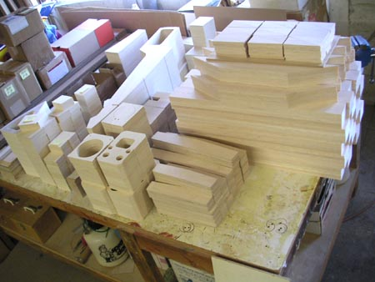
UPDATE #3 September 2004

Kit Progress

Right now I’m sure that most of you are interested in how the production of the kit is coming along. Well, I’ve been cutting templates, making jigs, and cranking out parts for the past two months or so. All of the aircraft plywood parts are cut (dihedral braces, certain bulkheads, retract mounts) as are all of the lite-ply parts (fuselage doublers, bulkheads, boat tail assembly, wheel well frames, etc…). Balsa production has started – the parts for the tail surfaces are nearly complete. The major part-cutting task still remaining is the ribs, which will require 14 different aluminum templates and a few hole-cutting jigs.
Parts is Parts – Here are just some of the finished parts for the R54 kit. The big stack on the right is balsa stabilizer parts. You can also see the two dihedral braces and a number of lite-ply parts including bulkheads, doublers, boat tail formers, wheel well frames, etc… Production quantity for the first run is 48 kits

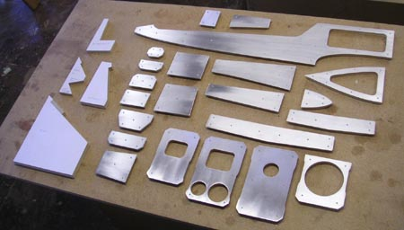
Obviously, the first run of any kit is always the toughest because of all the tooling. The plans were a lot of work; there is still an issue with printing them out, but I hope to have that solved soon. Once all the parts are cut, I need to build a proof model, taking photos as it’s built for the instruction book. This may all take another month, so please bear with me. This isn’t a quick-and-dirty design that’s being rushed to market. It’s a product that I hope to sell for the next ten years.

The kit price is still not finalized, but I see no reason to think it will vary from my ballpark figure of $400 to $500. In the box you will receive high-quality, american-made hardware, an aluminum turbine mount, a main fuel tank, full-size rolled plans, an instruction book with color photos, vinyl graphics, and some of the best wood you have ever seen. Robart is still working on the retract package which will feature a set of Mighty Mini retracts with wire struts to keep the price down. The plan is for BTE to offer the R54 kit along with optional accessory packages like the Robart Retracts, wheels and brakes, Handibond glue, and perhaps some others.
Just a few of the tools required to manufacture the accurate parts supplied in the R54 kit. The aluminum templates are pinned to the top of a stack of wood which is then sanded to shape with a spindle sander. Lots of work!

What You Will Need in Addition to the Kit

A few potential customers have inquired about what they will need to complete their R54. Besides your turbine and radio, not much! The items that come to mind are an Ultimate Air Trap (UAT), digital servos, and covering.

UAT - The plans do show the installation of a BVM Ultimate Air Trap, which I’ve been using in my prototype with great success. The UAT serves as a 4-ounce header tank, air trap, and fuel filter all in one. The main fuel tank is a 50-ounce Du-Bro, so total fuel capacity is 54 ounces. With my RAM 500, that translates into an eight-minute flight with plenty of reserve for landing. If you want to carry more fuel, there is room in the fuselage for a larger header tank.
R54 Update #3 – Page 2

Servos - Every turbine pilot has their own opinion on servos. This is an entry-level turbine model designed to fly at modest speeds with an eye towards economy. The place to economize, however, is not with your servos! I must insist on digital servos for all of the flight control surfaces. Prices for digitals are coming down, and there is a wide selection from all the radio manufacturers. Digital servos also offer an extra level of security against flutter thanks to their ability to “lock in” around neutral. I’ve had no problems with the Hitec servos used in the prototype and will use their specifications as minimum requirements, as follows:

Ailerons (2 servos) and Rudder (1 servo) Hitec HS-5625MG - 110 oz.in. @ 4.8V Dual BB, Metal Gears
Flaps (2 servos) and Elevator (1 servo) Hitec HS-5645MG - 143 oz.in. @ 4.8V Dual BB, Metal Gears
Nosewheel Steering (1) and Retract Valve (1) Hitec HS-225MG - 54 oz. in. @ 4.8V Top BB, Metal Gears

Covering - Your choice of plastic film or glass and paint. In keeping with the simple theme of the model, I suggest sticking with a high-quality film like Monokote or Ultracote. There are some open rib bays near each wingtip, but the kit will include plenty of balsa to sheet the entire wing if you want to go the glass and paint route.

Engine Mounts

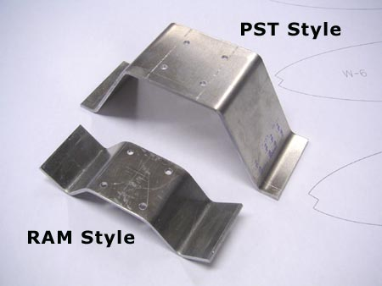
Right now, I plan on offering two different types of aluminum mounts for attaching your turbine to the airframe. The first is similar to what I am using on the prototype, so it will be called the RAM-style mount. It is designed to attach to the “straps and tabs” mounting system that was provided with the RAM. The aluminum mount is compact and light, and unobtrusive to the eye. The second aluminum mount was designed for the PST-600R, which is the engine shown on the plans and in the instruction book. The PST-style mates with the “flat” mounting straps provided with the PST. It’s a little larger, wider, and heavier, and will be a little more noticeable on the exposed engine.

Of course, there are several other suitable turbines on the market and it would be difficult to make special aluminum mounts for all of them. One of my customers has an FTE-500 which comes with a flat mount. Unfortunately, my aluminum PST mount won’t quite fit without some surgery. I don’t even know what kind of mounting straps are provided with other engines like the Wren 54, SWB Samba, and Simjet 1200. There is, however, a simple solution to this problem. BVM offers a set of straps and tabs for these engines, just like what came with the RAM 500. I suggest that builders order the straps and tabs from BVM ($48) and then use the RAM-style aluminum mount to attach their turbine to the airframe. Yes, it is an extra expense, but remember that the Reaction 54 does NOT require other expensive items such as a bypass, tailpipe, custom-molded fuel tanks, specialized "jet" wheels and tires, or a pneumatic brake system.
Turbine Mounts – These are the two styles that have been developed so far. The question is, do we need more? Most engines could be attached to the RAM style mount using the straps and tabs available from BVM.

When the time comes to order, I will probably ask what type of mount you wish to use and include it in the box when it’s shipped. I still consider this an open topic and would appreciate any input from turbine owners with alternative ideas.
R54 Update #3 – Page 3

Flight Goal Met

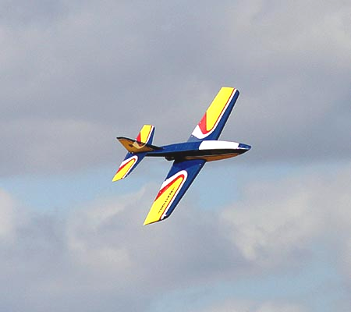
Flight testing on the R54 was completed long ago, but there was one personal goal that I wanted to meet with this design. I wanted to fly it at my local club field near Medford, Oregon. The paved runway is 400-feet long, which is on the short side for typical turbine models. Takeoff was never an issue, but landing was a concern. The R54 doesn’t need anywhere near that much length for rollout, but the trick is getting it to settle down where you want it to. As mentioned in previous updates, my prototype will float at times. This has been addressed with larger flaps on the production version.

Well, the club put on an airshow a couple of weekends ago and talked me into bringing out the R54. Lacking time to practice at the field, my first flights were in front of quite a crowd. To my pleasure, the R54 flew beautifully and did two fantastic landings right in the center of the runway. I would estimate it used the center third of the runway for rollout, maybe 150 ft. at the most.

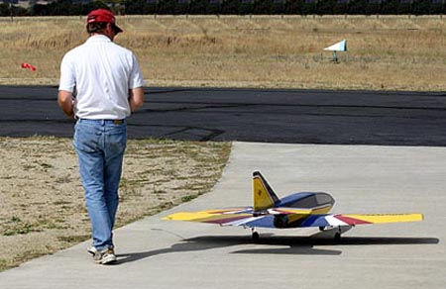
The next day, I was feeling pretty confident and for some reason allowed it to come in just a little hotter. She floated past me and I made the mistake of trying to force it down rather than go around. Big mistake! It was perhaps the worst landing of my life. The R54 got into the dreaded “bunny hop” mode, bouncing higher each time the nose wheel hit. The final hit looked like it was straight down, but the balsa nose block had no damage so the Robart nose wheel must have taken the full force. The silver lining of this incident is that the R54 has now undergone a severe landing gear test and came through with flying colors! (In Washington, this is called “spin”). There was zero damage to the airframe. The Robarts did not collapse and also came through with no damage. All three wire struts were bent back a little, but I merely pulled them by hand back into alignment. One of the main gear struts did twist in the trunion block, but that was a simple fix. Besides the blow to my ego, it was pretty much a non-event. It did reinforce the simple rules that you must let the model settle down by itself and decide early if a go-around is in order. Duh.

One benefit of attending the airshow was that I got a number of beautiful flight shots from fellow club member, Joe Stagg. Thanks Joe!

Well, it’s time to tackle those rib templates! As always, feel free to contact me with any questions, comments, criticisms, or suggestions you may have. Talk to you soon,

Bruce Tharpe

