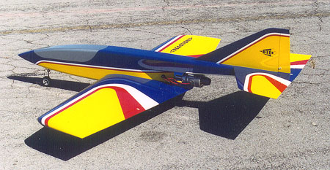
UPDATE #2 May 31, 2004

Man, am I pumped about this airplane!

I just returned from a great little jet rally in Madras, Oregon. The Reaction 54 made its public flying debut and walked away with the award for best turbine. To say I am happy with this design is a huge understatement.
Reaction 54 in its original configuration without flaps, and engine aligned with fuselage top.

Changes for the Better
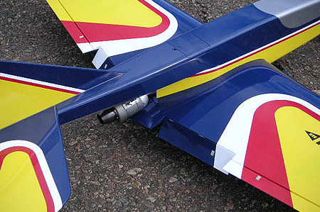
There have been several improvements to the prototype model since the last update. The biggest change was the addition of flaps. I originally thought that the massive size of the airframe and the thick wing would create enough drag without flaps, but I was flat-out wrong. Even when going to idle power on the downwind leg of the landing approach, the R54 would just fly on past, content with residual thrust to keep it floating along. If a long, low, stretched-out landing approach pattern was used, it would finally pay off and settle in for a landing, but that’s not how I wanted it to handle.
Flaps were added primarily for drag. These flaps drop about 60 degrees and provide a substantial braking effect. This photo also shows the small rear hatch on top of the fuselage for access to the manual fuel shutoff valve and fuel filling line.
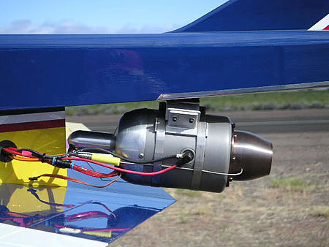
So, with a little surgery, three-inch-wide flaps were added to the wing, along with a servo for each. Truth is, they are really more airbrake than flap. The model didn’t need more lift; it needed more drag. And they work! Testing in still air makes me wish they were even a bit bigger. At Madras, there was a stiff breeze and the model slowed down nicely. The kit version of the R54 will have bigger flaps and ailerons.

I’ve had experienced turbine pilots suggest that popping the ailerons up to make them spoilerons would also help cure the floating tendency. Even though I had this set up at Madras, I never felt the need to try it. Perhaps I’ll have a chance to experiment with them in still air before the next update.

Another change to the model involves the thrust angle of the turbine. At first, the turbine was aligned with the line of flight (see the top photo), but the R54 displayed a definite nose-up tendency when power was applied. With a bit of trial and error, a neutral thrust angle was found. As you can see in the photo it is a pretty severe angle, but now it exhibits no power-induced pitch change. It’s not pleasing to my eye, but it does have the added advantage of angling the hot jet exhaust even further away from the structure than it did originally.
The engine thrust angle shown here was finally determined through testing. Looks funky, but it works! Notice how the front of the engine is protected from foreign object damage (FOD) from below by the trailing edge of the wing.

A Tough Test

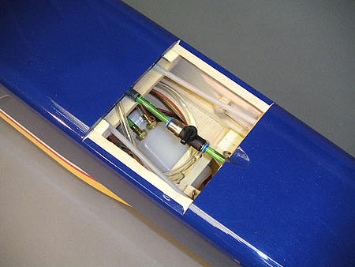
As you can tell, I’ve done a fair amount of flying with this model and it just continues to amaze me with its solid handling characteristics. Perhaps the most notable outing so far was last October when we took it out to Black Rock Dry Lake in northern Nevada. There comes a time in the development of a kit when it must be subjected to the ultimate test. Structural integrity has to be proven in the air, and Black Rock provided a safe, secluded area where it could pass or fail without the stress of an audience. Understand, I hate to do this. It’s one thing to risk a Venture 60 during testing; it’s quite another to put a turbine model through this torture, not knowing if you’re going to go home with bag full of balsa bits and twisted metal or not. During the course of that two-day outing, I banked and yanked my prototype around far beyond what I would hope any sane jet jock would attempt. Then I gritted my teeth and put it through several full-power extended dives, pushing it to speeds I really don’t like, speeds that make me cringe just watching.

The result? Nothing. No burbles, no stalls, no cracks, no flutter. I do not want you to fly your Reaction 54 like this, but it is satisfying to know that it can take it.
The rear hatch has been removed in this photo. The dark object at the top center is the manual fuel shutoff valve, shown in the “off” position. On either side of the fuselage you can see the plastic tube housings for the steel push-pull cables used to control the rudder and elevator. Below the shutoff valve is a UAT, which is a four-ounce header tank with a special filter bag that is designed to trap air bubbles. You can also see a coiled fuel tube that can be pulled out for filling.

Engine Update

The Ram 500 in the prototype model is still a little bugger to start, but things have improved. The ECU software was recently updated, and a bigger battery with SCR cells was installed in the model. Once it starts, it is very reliable unless you move the throttle stick from high to low too quickly. I’ve had a few flameouts because of my left thumb, but that just provided me with opportunities to test the gliding performance of the R54! As you might expect with its huge wing, it’s really no sweat to land without power. I would venture to say you could probably recover from just about any flameout unless you are flying extremely low and slow. This should be a comforting thought to new turbine pilots (…it is to me!).

After considerable research, I’ve recently purchased a new turbine for my second prototype. It’s a PST-600R, which is the same physical size as the RAM 500, but puts out about 14 pounds of thrust. This turbine and the installation of its components will be clearly shown on the plans and in the kit instruction booklet.

Speaking of the Kit…

You may be glad to hear that the Reaction 54 is now top priority at BTE. I’m making progress on the plans and will be starting construction of the second model (for instruction book photos) very soon. It’s too early to say right now when the kit will be ready or how much it will cost. However, I will be sending more updates like this much more frequently in the coming weeks, and that kind of information will be passed along sooner than later. There are a lot of builders chomping at the bit for this model, and I’m feeling the pressure, believe me! My goal is to make every builder feel like it was worth the wait. It is, after all, an award-winning design . . . ☺

Bruce Tharpe

